Experiment 1 : Implement and demonstrate the FIND-S algorithm for finding the most specific hypothesis based on a given set of training data samples.
# Find-S Algorithm in Python
def find_s(examples):
# Step 1: Initialize hypothesis with the first positive example
for example in examples:
if example[-1] == "Yes":
hypothesis = example[:-1]
break
# Step 2: For each positive example, generalize hypothesis
for example in examples:
if example[-1] == "Yes":
for i in range(len(hypothesis)):
if hypothesis[i] != example[i]:
hypothesis[i] = "?"
return hypothesis
# Training data (EnjoySport Example)
data = [
['Sunny', 'Warm', 'Normal', 'Strong', 'Warm', 'Same', 'Yes'],
['Sunny', 'Warm', 'High', 'Strong', 'Warm', 'Same', 'Yes'],
['Rainy', 'Cold', 'High', 'Strong', 'Warm', 'Change', 'No']
]
final_hypothesis = find_s(data)
print("Most Specific Hypothesis:", final_hypothesis)

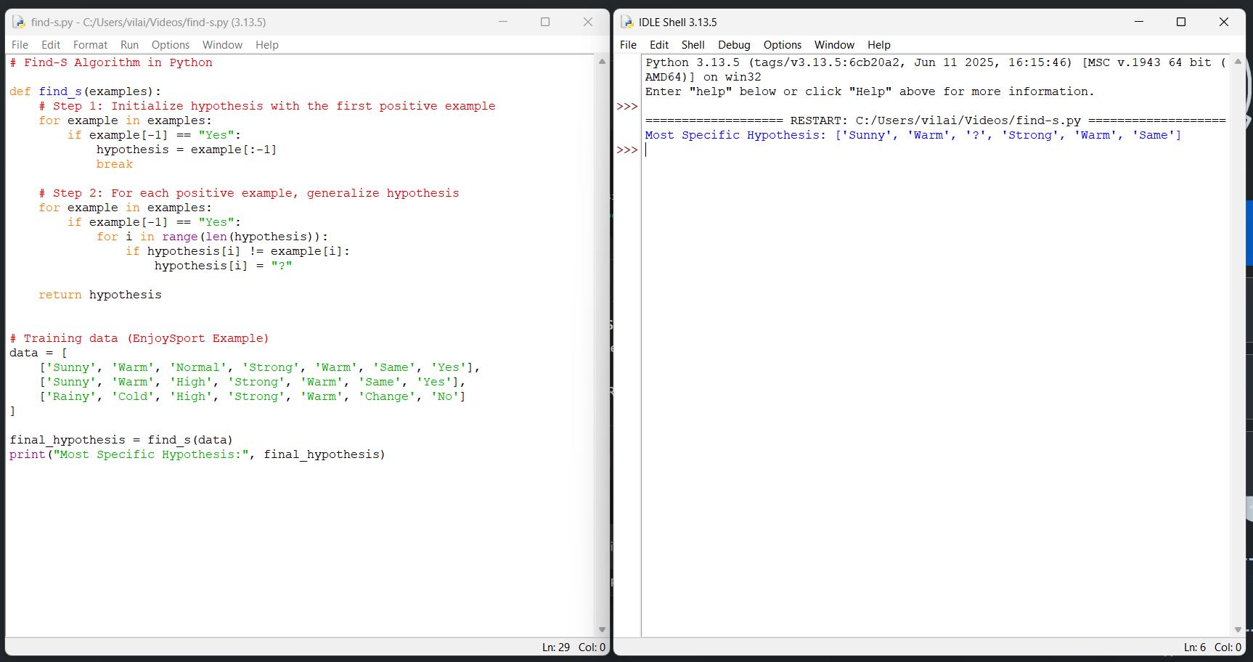
Experiment 2 : For a given set of training data examples stored in a .CSV file, implement and demonstrate the Candidate-Elimination algorithm in python to output a description of the set of all hypotheses consistent with the training examples
# Candidate Elimination Algorithm in Python
def more_general(h1, h2):
"""Check if hypothesis h1 is more general than h2"""
more_general_parts = []
for x, y in zip(h1, h2):
mg = x == "?" or (x != "?" and x == y)
more_general_parts.append(mg)
return all(more_general_parts)
def candidate_elimination(data):
# Initialize S as the first positive example
S = None
for row in data:
if row[-1] == "Yes":
S = row[:-1]
break
# Initialize G as most general hypothesis
G = [["?" for _ in range(len(S))]]
for row in data:
example, label = row[:-1], row[-1]
if label == "Yes":
# Remove from G any hypothesis inconsistent with example
G = [g for g in G if more_general(g, example)]
# Update S to be as specific as possible
for i in range(len(S)):
if S[i] != example[i]:
S[i] = "?"
else: # Negative example
# Remove S if it incorrectly classifies negative example
if more_general(S, example):
# Specialize G
new_G = []
for g in G:
for i in range(len(g)):
if g[i] == "?":
new_h = g.copy()
new_h[i] = S[i]
if not more_general(new_h, example):
new_G.append(new_h)
G = new_G
return S, G
# Training data (EnjoySport)
dataset = [
['Sunny','Warm','Normal','Strong','Warm','Same','Yes'],
['Sunny','Warm','High','Strong','Warm','Same','Yes'],
['Rainy','Cold','High','Strong','Warm','Change','No'],
['Sunny','Cold','High','Strong','Cool','Change','Yes'],
['Cloudy','Warm','Normal','Weak','Warm','Same','Yes'],
]
S, G = candidate_elimination(dataset)
print("Specific Boundary (S):", S)
print("General Boundary (G):", G)
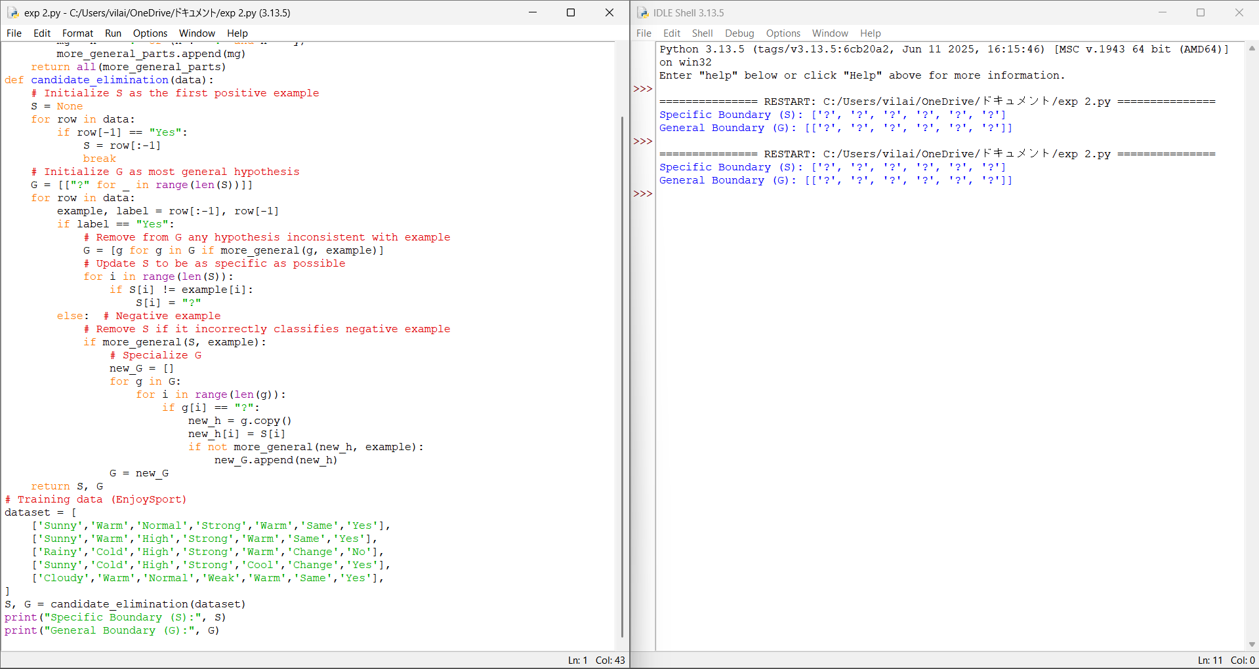

Experiment 3 : Demonstrate the working of the decision tree based ID3 algorithm. Use an appropriate data set for building the decision tree and apply this knowledge to classify a new sample.
import math
# Calculate entropy
def entropy(data):
labels = [row[-1] for row in data]
unique_labels = set(labels)
ent = 0
for label in unique_labels:
p = labels.count(label) / len(labels)
ent -= p * math.log2(p)
return ent
# Calculate Information Gain
def info_gain(data, col):
total_entropy = entropy(data)
values = set([row[col] for row in data])
weighted_entropy = 0
for v in values:
subset = [row for row in data if row[col] == v]
weighted_entropy += (len(subset) / len(data)) * entropy(subset)
return total_entropy - weighted_entropy
# ID3 Algorithm
def id3(data, features):
labels = [row[-1] for row in data]
# If all outputs are same → return that label
if labels.count(labels[0]) == len(labels):
return labels[0]
# If no features left
if not features:
return max(set(labels), key=labels.count)
# Find best attribute
gains = [info_gain(data, col) for col in features]
best_col = features[gains.index(max(gains))]
best_feature = "Feature_" + str(best_col)
tree = {best_feature: {}}
values = set(row[best_col] for row in data)
for v in values:
subset = [row for row in data if row[best_col] == v]
if not subset:
tree[best_feature][v] = max(set(labels), key=labels.count)
else:
new_features = [f for f in features if f != best_col]
tree[best_feature][v] = id3(subset, new_features)
return tree
# Sample dataset (Outlook, Temperature, Humidity, Wind, Play?)
dataset = [
['Sunny', 'Hot', 'High', 'Weak', 'No'],
['Sunny', 'Hot', 'High', 'Strong', 'No'],
['Overcast','Hot','High', 'Weak', 'Yes'],
['Rain', 'Mild', 'High', 'Weak', 'Yes'],
['Rain', 'Cool', 'Normal', 'Weak', 'Yes'],
['Rain', 'Cool', 'Normal', 'Strong', 'No'],
['Overcast','Cool','Normal','Strong','Yes'],
['Sunny', 'Mild', 'High', 'Weak', 'No'],
]
# Run ID3
features = [0, 1, 2, 3] # column indices
tree = id3(dataset, features)
print("Decision Tree:")
print(tree)
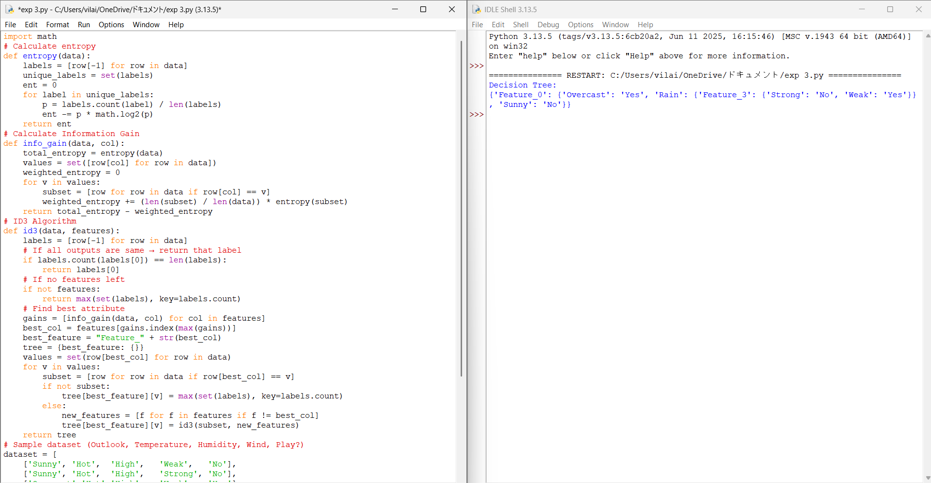
Experiment 4 : Build an Artificial Neural Network by implementing the Backpropagation algorithm and test the same using appropriate data sets.

# Perceptron Learning Algorithm for AND Gate
# Training data: [x1, x2, target]
training_data = [
[0, 0, 0],
[0, 1, 0],
[1, 0, 0],
[1, 1, 1]
]
# Initialize weights and bias
w1 = 0
w2 = 0
b = 0
lr = 1 # learning rate
# Activation function
def activation(x):
return 1 if x >= 0 else 0
# Training loop
for epoch in range(10):
print("Epoch:", epoch)
errors = 0
for x1, x2, target in training_data:
y = activation(w1*x1 + w2*x2 + b)
e = target - y
# Update rule
w1 = w1 + lr * e * x1
w2 = w2 + lr * e * x2
b = b + lr * e
errors += abs(e)
print(f"Input: {x1, x2}, Target: {target}, Output: {y}, Error: {e}")
if errors == 0:
print("Training complete!")
break
print("\nFinal Weights:")
print("w1 =", w1, ", w2 =", w2, ", bias =", b)
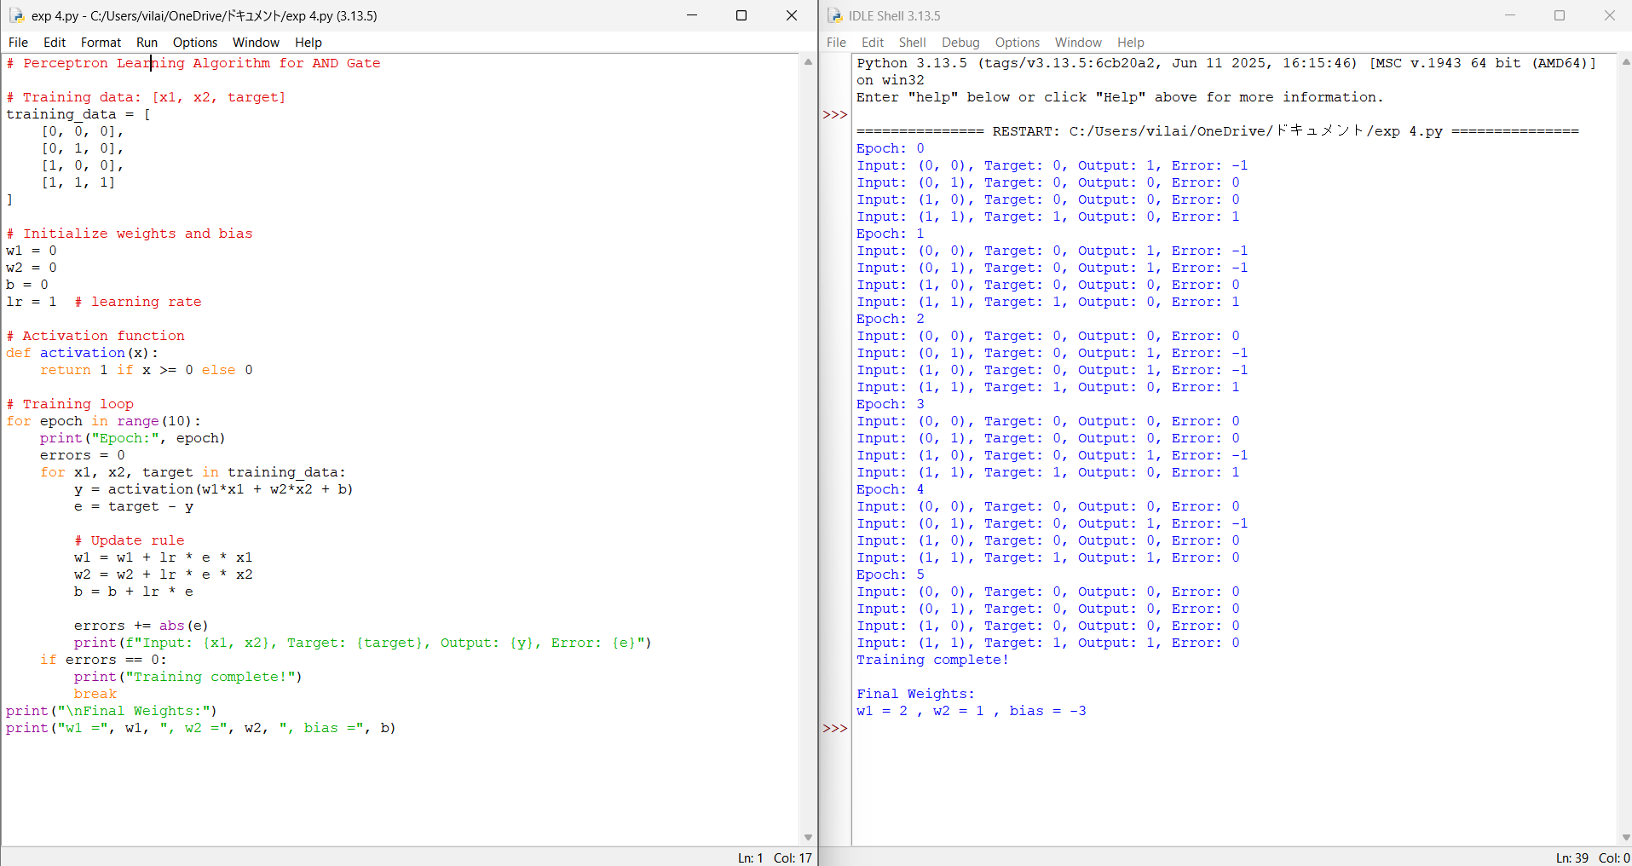

Experiment 5 : Write a program for Implementation of K-Nearest Neighbours (K-NN) in Python
# KNN Algorithm Implementation in Python
import math
# Calculate Euclidean Distance
def distance(p1, p2):
return math.sqrt(sum((a - b)**2 for a, b in zip(p1, p2)))
# KNN Function
def knn(training_data, test_point, k=3):
distances = []
for features, label in training_data:
dist = distance(features, test_point)
distances.append((dist, label))
# Sort by distance
distances.sort(key=lambda x: x[0])
# Get K nearest labels
k_neighbors = [label for _, label in distances[:k]]
# Majority vote
prediction = max(set(k_neighbors), key=k_neighbors.count)
return prediction
# Training dataset: ([features], label)
dataset = [
([2, 4], "A"),
([4, 6], "A"),
([4, 2], "A"),
([9, 10], "B"),
([10, 12], "B"),
([11, 9], "B")
]
test_sample = [5, 5]
pred = knn(dataset, test_sample, k=3)
print("Predicted Class:", pred)
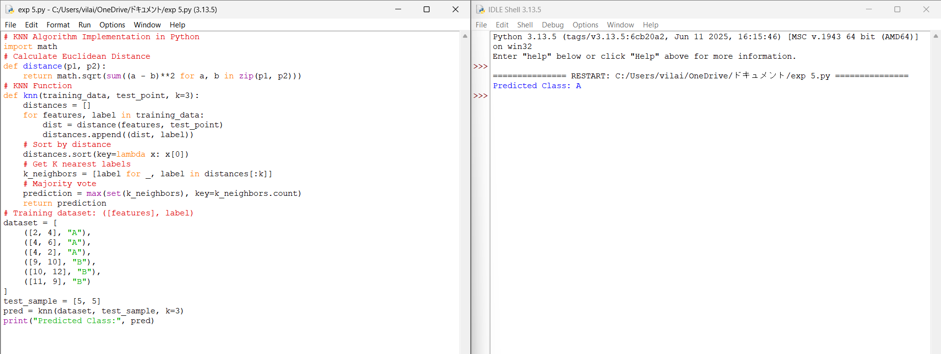

Exp 6 : Write a program to implement Naïve Bayes algorithm in python and to display the results using confusion matrix and accuracy.
Program:
# Import required libraries
import numpy as np
from sklearn.naive_bayes import GaussianNB
from sklearn.metrics import confusion_matrix, accuracy_score
from sklearn.model_selection import train_test_split
# Features: [Height, Weight]
X = np.array([
[160, 55],
[165, 60],
[170, 65],
[175, 70],
[180, 80],
[155, 48],
[158, 50],
[162, 54]
])

# Labels: 0 = Female, 1 = Male
y = np.array([0, 0, 1, 1, 1, 0, 0, 0])
X_train, X_test, y_train, y_test = train_test_split(
X, y, test_size=0.25, random_state=42
)
model = GaussianNB()
model.fit(X_train, y_train)
y_pred = model.predict(X_test)
cm = confusion_matrix(y_test, y_pred)
accuracy = accuracy_score(y_test, y_pred)
print("Confusion Matrix:")
print(cm)
print("\nAccuracy:")
print(accuracy)
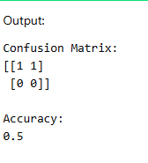
Exp 7 : Write a program to implement Logistic Regression (LR) algorithm in python
Program:
import math

# Sigmoid function
def sigmoid(z):
return 1 / (1 + math.exp(-z))

# Training data
X = [[1, 1], [2, 1], [3, 2], [4, 3]]
y = [0, 0, 1, 1]

# Initialize weights and bias
w1 = w2 = b = 0
lr = 0.1

# Training using Gradient Descent
for _ in range(1000):
for i in range(len(X)):
z = w1 * X[i][0] + w2 * X[i][1] + b
y_pred = sigmoid(z)

w1 += lr * (y[i] - y_pred) * X[i][0]
w2 += lr * (y[i] - y_pred) * X[i][1]
b += lr * (y[i] - y_pred)

# Prediction
print("Logistic Regression Predictions:")
for i in range(len(X)):
z = w1 * X[i][0] + w2 * X[i][1] + b
print(sigmoid(z))
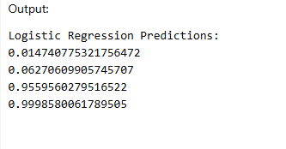

Exp 8: Write a program to implement Linear Regression (LR) algorithm in python
Program:
X = [1, 2, 3, 4, 5]
y = [2, 4, 5, 4, 5]
n = len(X)
mean_x = sum(X) / n
mean_y = sum(y) / n
num = den = 0
for i in range(n):
num += (X[i] - mean_x) * (y[i] - mean_y)
den += (X[i] - mean_x) ** 2
m = num / den
c = mean_y - m * mean_x
print("Slope (m):", m)
print("Intercept (c):", c)
print("Predicted values:")
for x in X:
print(m * x + c)
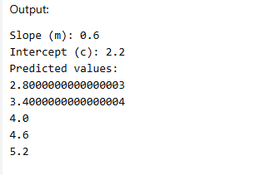

Exp 9: Compare Linear and Polynomial Regression using Python
Program:
import numpy as np
# Data
X = np.array([1, 2, 3, 4, 5])
y = np.array([2, 4, 5, 4, 5])
# Linear Regression
coef = np.polyfit(X, y, 1)
linear_pred = np.polyval(coef, X)
# Polynomial Regression (degree = 2)
poly_coef = np.polyfit(X, y, 2)
poly_pred = np.polyval(poly_coef, X)
# Mean Squared Error
linear_mse = np.mean((y - linear_pred) ** 2)
poly_mse = np.mean((y - poly_pred) ** 2)
print("Linear Regression MSE:", linear_mse)
print("Polynomial Regression MSE:", poly_mse)
if poly_mse < linear_mse:
print("Polynomial Regression performs better")
else:
print("Linear Regression performs better")
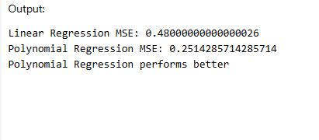

Exp 10: Write a Python Program to Implement Expectation & Maximization Algorithm
Program:
# EM Algorithm Example – Coin Toss
import random
# Observed data (number of heads in 10 tosses)
data = [5, 9, 8, 4, 7]
# Initial probabilities
pA = 0.6
pB = 0.5
for iteration in range(5):
expA = expB = 0
for heads in data:
probA = (pA ** heads) * ((1 - pA) ** (10 - heads))
probB = (pB ** heads) * ((1 - pB) ** (10 - heads))
weightA = probA / (probA + probB)
weightB = probB / (probA + probB)
expA += weightA * heads
expB += weightB * heads
# Maximization step
pA = expA / (10 * len(data))
pB = expB / (10 * len(data))
print(f"Iteration {iteration+1}: pA={pA:.3f}, pB={pB:.3f}")
